AI ASSISTED CODING - 17.3

P.Deepak
2303A52179
Batch - 42

Task 1 Employee Dataset Cleaning
Task:
Use AI assistance to clean an employee information dataset. Instructions:
- Handle missing values in salary, designation, and experience
- Remove duplicate employee IDs
- Standardize text values (job titles in lowercase)
- Encode categorical features (designation, employment_type)

Prompt:
Employee Dataset Cleaning . Use AI assistance to clean an employee information dataset. Instructions: • Handle missing values in salary, designation, and experience • Remove duplicate employee IDs • Standardize text values (job titles in lowercase) • Encode categorical features (designation, employment_type) Expected Output: A clean dataset suitable for HR analytics and prediction tasks. Give me code for this dataset and give me proper infomation of the employees and and give me some invalid emplyee information.

Code & output:

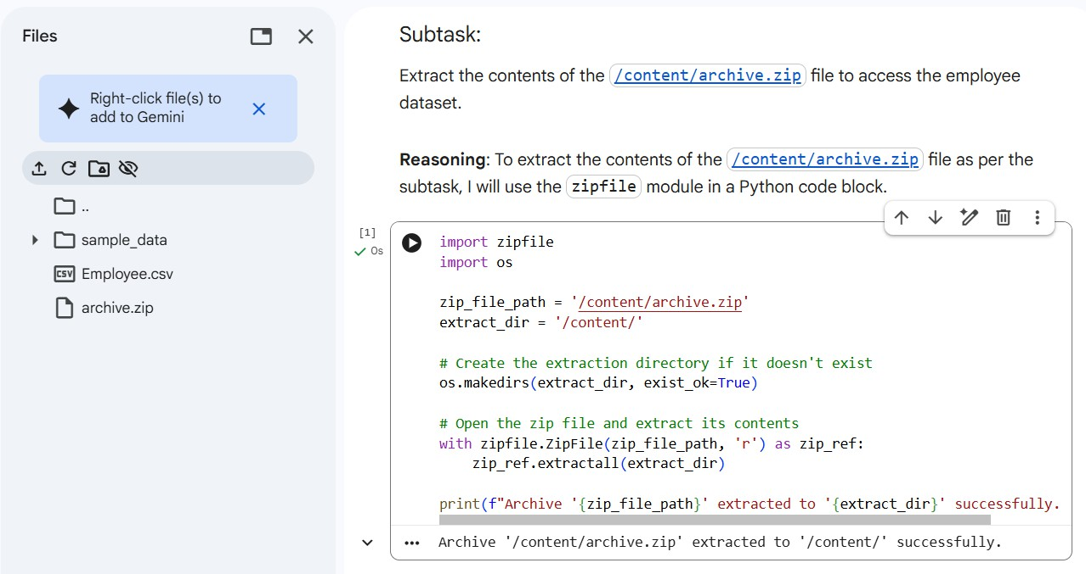
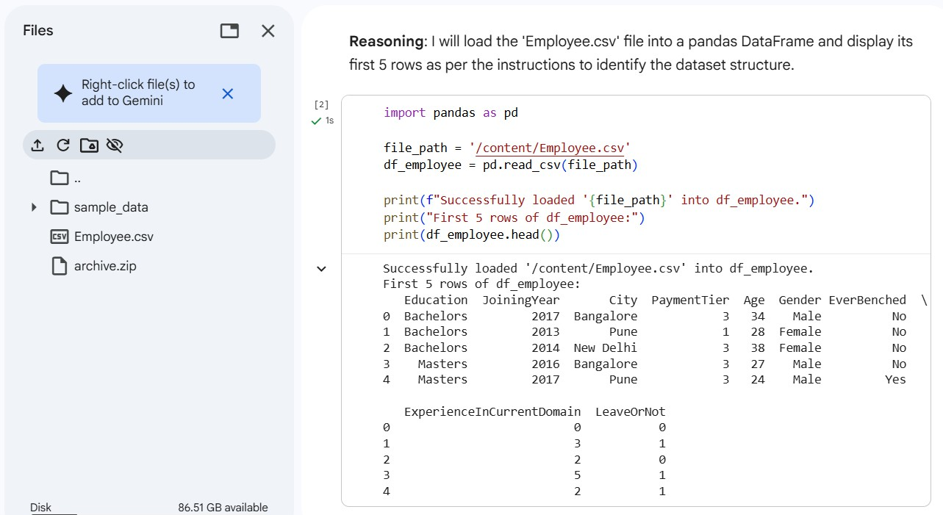
Load Employee Dataset

Handle Missing Values

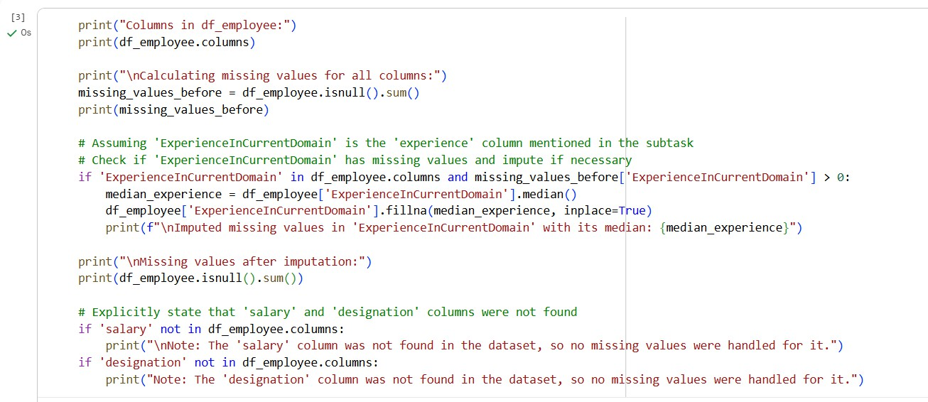

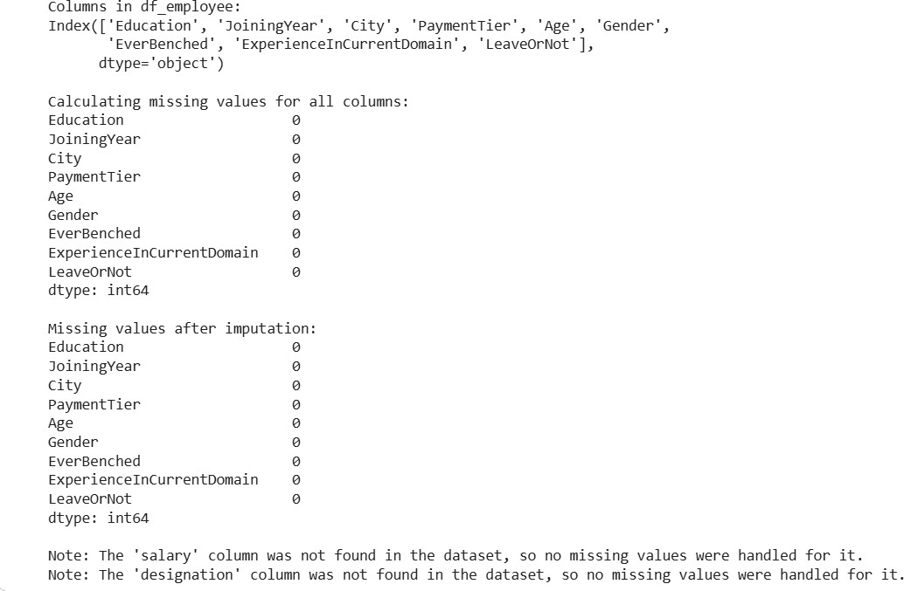

Remove Duplicate Employee IDs

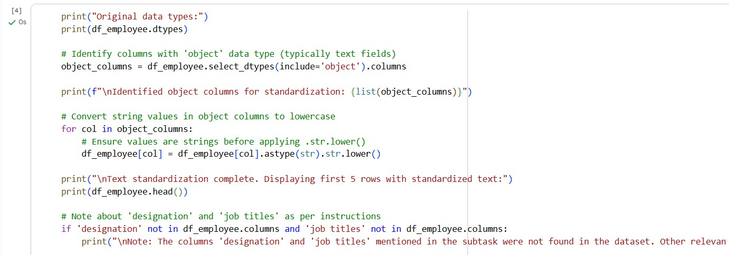

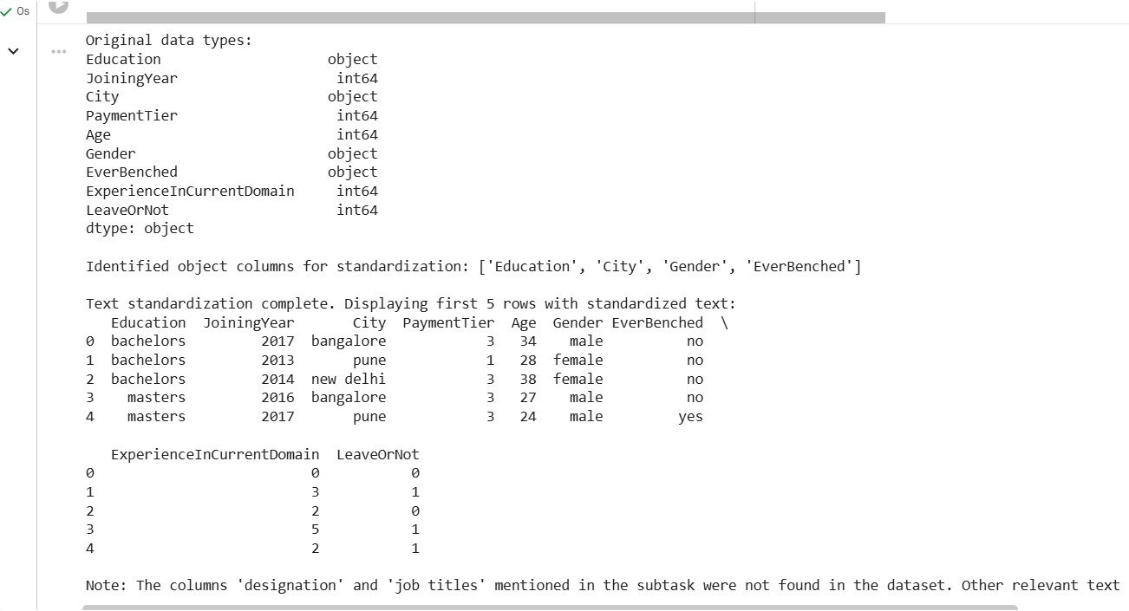
Encode Categorical Features

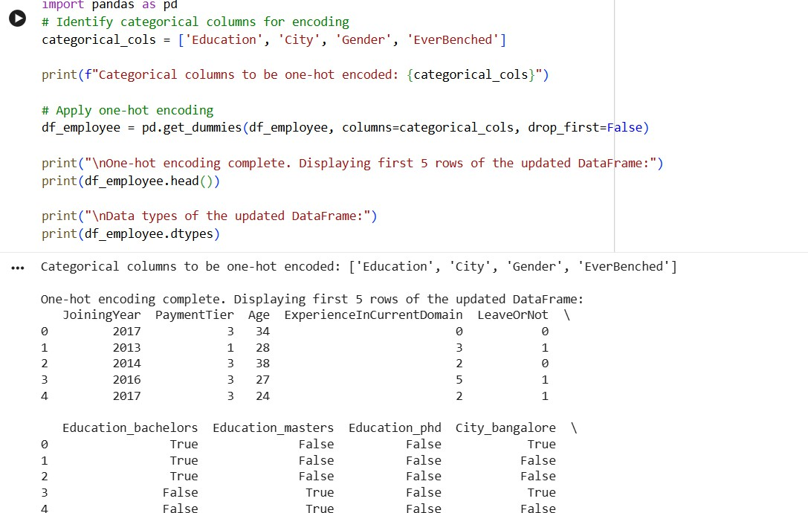

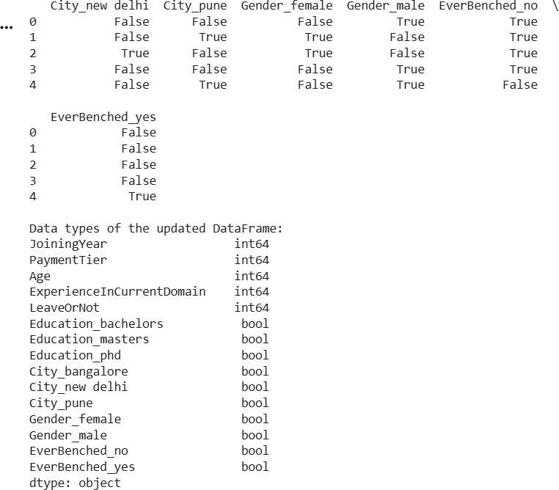

Identify Invalid Employee Information

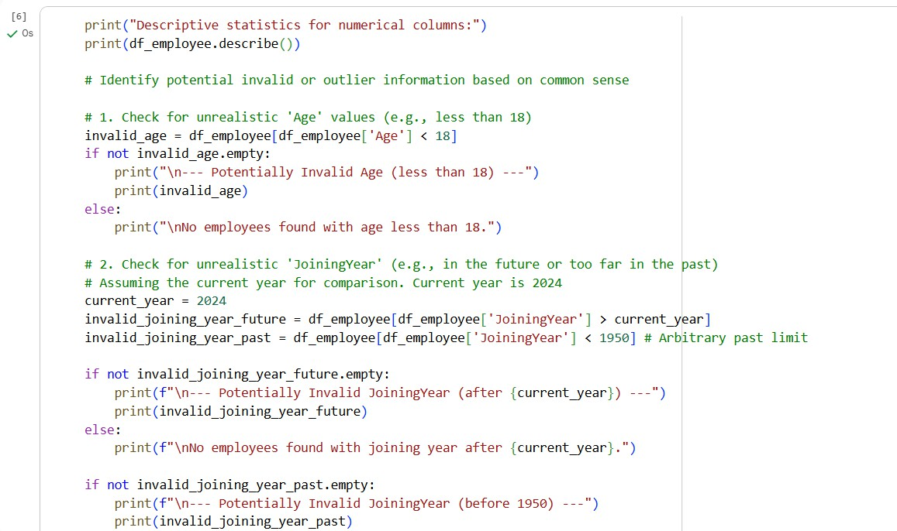
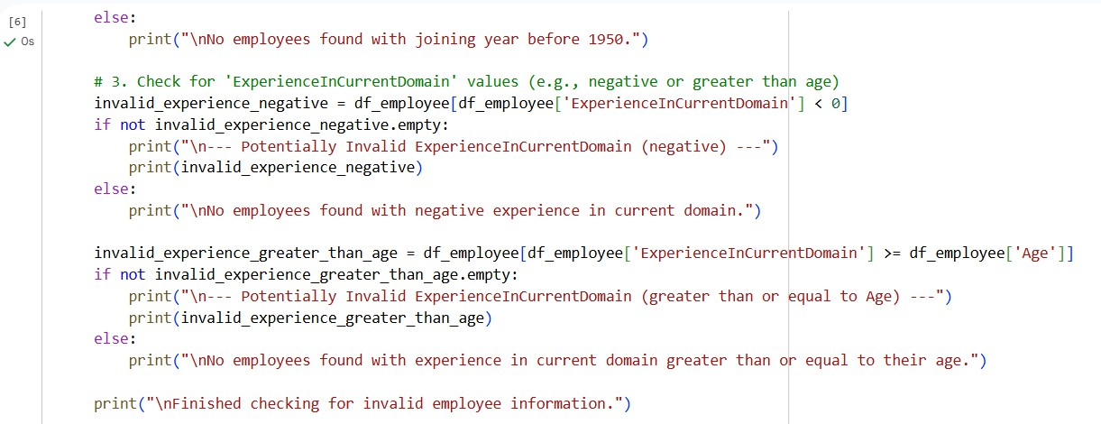

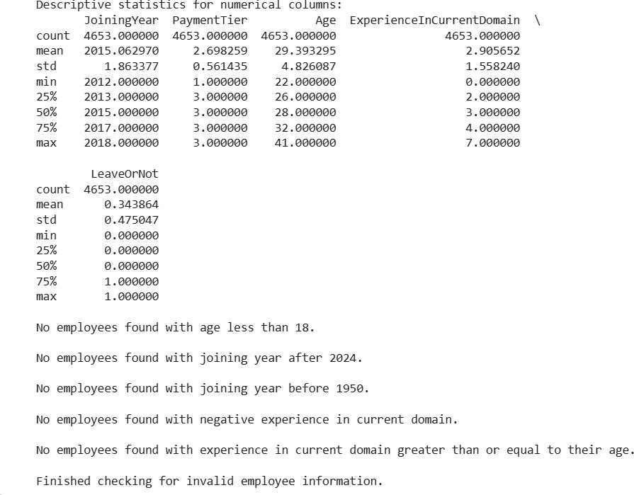

Display Cleaned Dataset Information
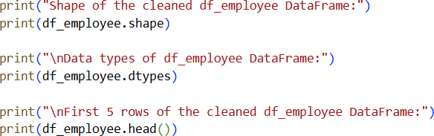

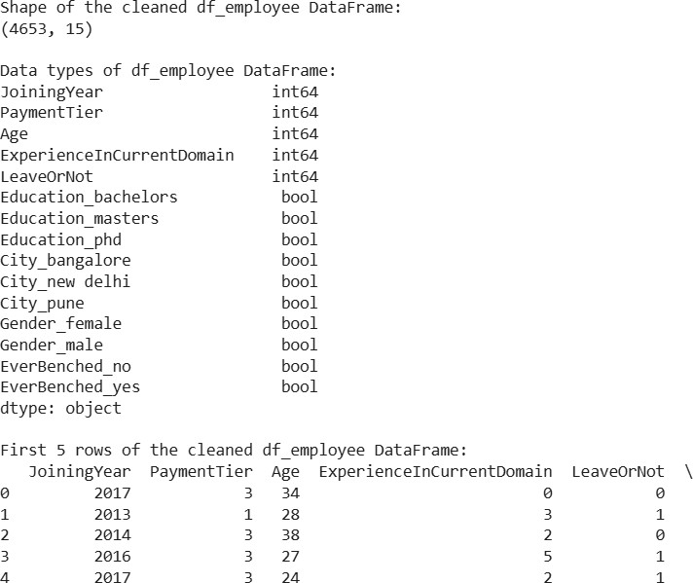

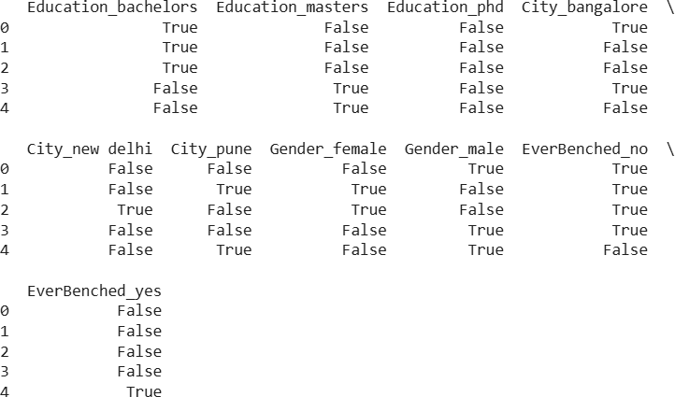

Justification:
- MissingValuesHandling
  - Salary→Median:Salarydistributionsareoftenskewed; median is robust to outliers.

  - Designation→Mode:Mostfrequentjobtitlemaintains categorical consistency.
  - Experience→Mean:Numericalfield;meanpreservesoverall distribution.
- DuplicateRemoval
  - Removingduplicateemployee_idensuresdataintegrityand avoids biased analytics.
- Text Standardization
  - Convertingdesignationstolowercaseeliminatescase-sensitive inconsistencies (e.g., “Manager” vs “manager”).
- CategoricalEncoding
  - Machinelearningmodelsrequirenumericalinputs;encoding converts text into usable numeric form.

Task 2 – Student Performance Data Preprocessing
Task:
Preprocess student performance data using AI assistance.

Prompt:
Preprocess a student performance dataset.

Instructions:
- Convert exam_date column into datetime format
- Extract new features (month, semester, day)
- Normalize total_marks
- Detect and handle outliers in marks using IQR or Z-score

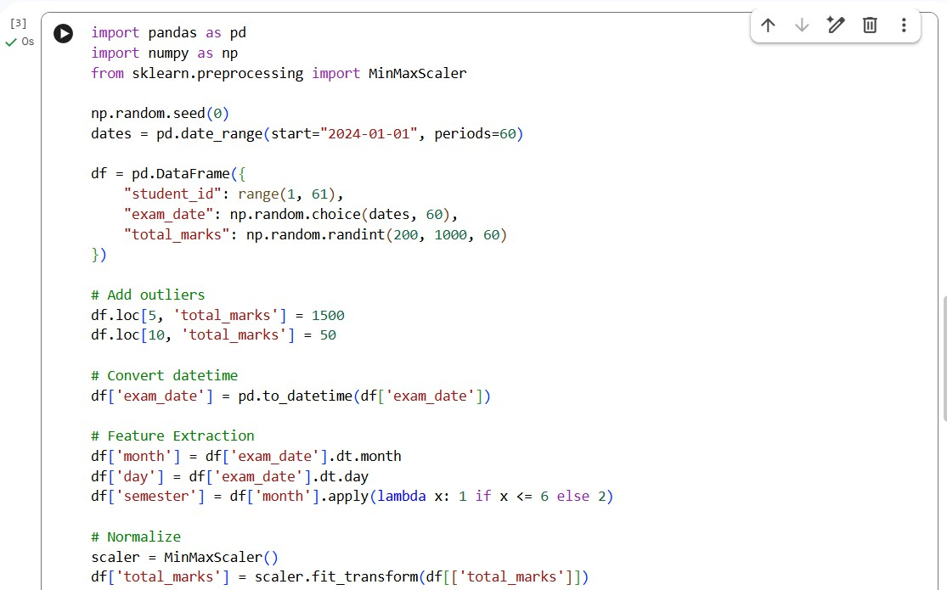
Code & Output

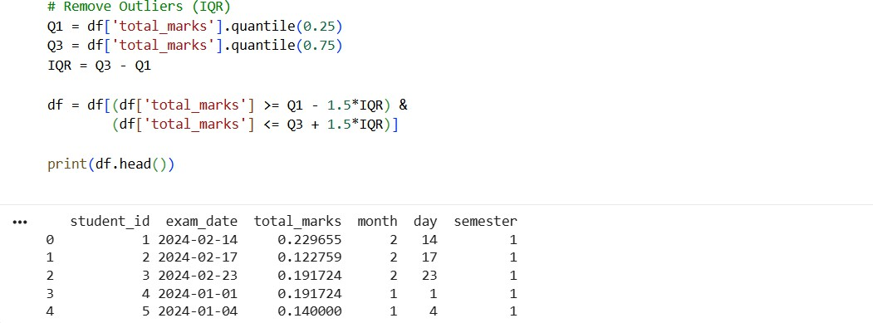
Justification:
Datetime conversion → enables time-based analysis Feature extraction → captures patterns (semester trends) MinMax scaling → brings values to 0–1 range

Outlier removal → improves model accuracy

Task 3 – Student Health Data Preparation

Task:

Clean and preprocess student health records using AI scripts.

Prompt:

Prepare a student health dataset for machine learning.

Instructions:

- Handle missing values in height, weight, BMI

- Encode categorical features (medical_condition, fitness_status)

- Scale numerical features using standard scaling

- Split dataset into training and testing sets

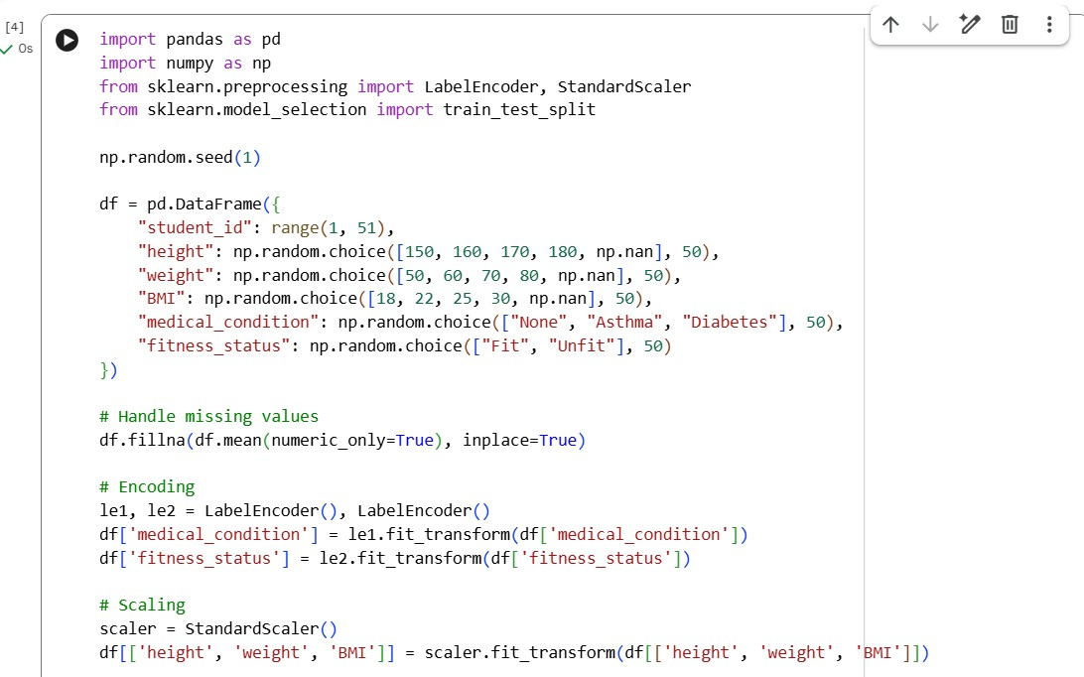
Code&output:

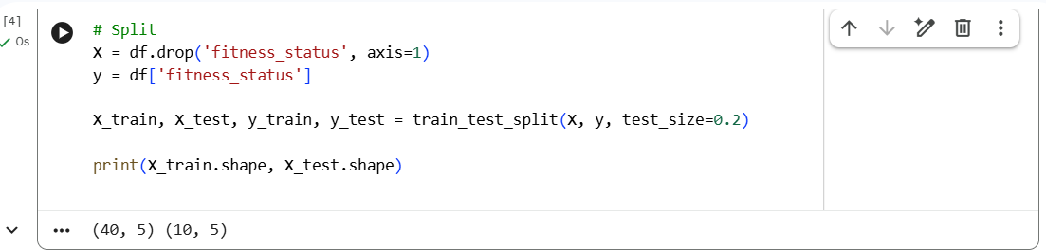
Justification:

Mean imputation → preserves dataset size Encoding → converts categorical to numeric Standard scaling → required for ML algorithms Train-test split → evaluates model performance

Task 4: Real-Time Application: Ride-Sharing Data Cleaning
Scenario:
A ride-sharing company has trip data with errors.

Prompt:
Clean a ride-sharing dataset.

Requirements:
- Standardize pickup and drop locations
- Fill missing fare amounts with median values
- Remove duplicate ride entries
- Normalize driver ratings
- Generate a summary of data improvements

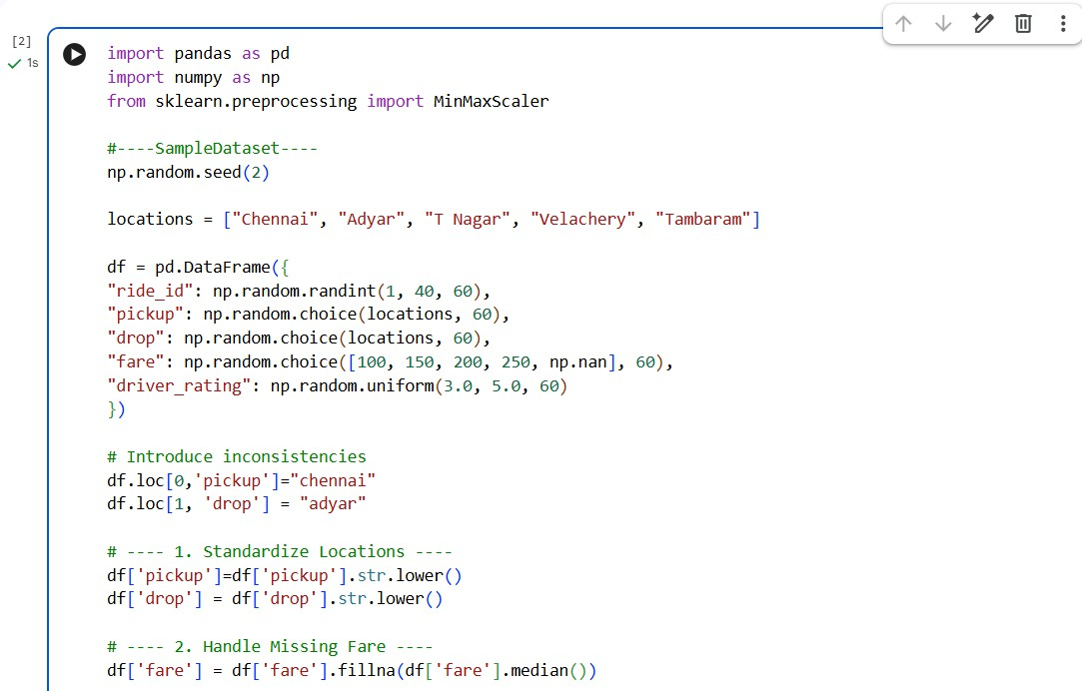
Code:

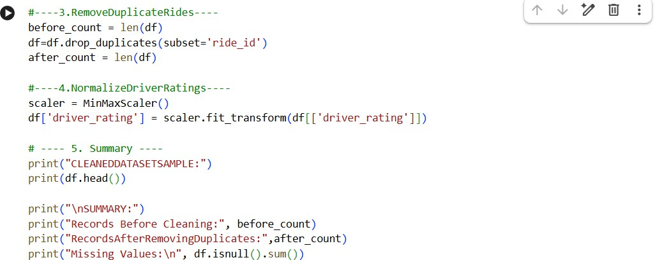

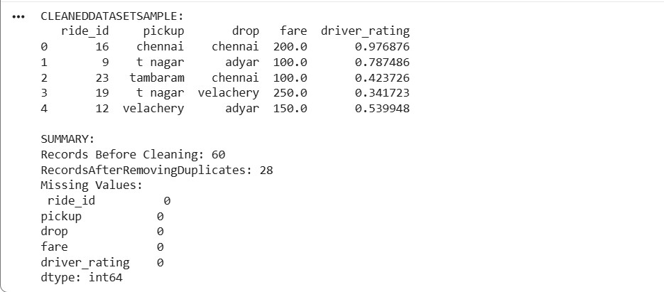
Output:

Justification:
Location standardization → avoids duplication issues Median for fare → robust to extreme values Duplicate removal → ensures accurate records Normalization → fair comparison of ratings
Summary → verifies cleaning effectiveness

